Header ( Styling )

The sx prop lets you add any valid CSS to an element



Using **sx** prop we can directly apply style. It is Custom Inline CSS Styling provided by MIUI System

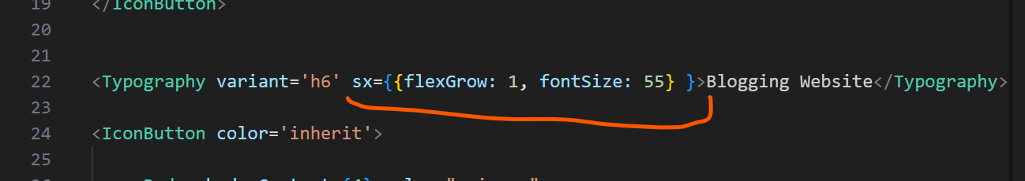

O/P



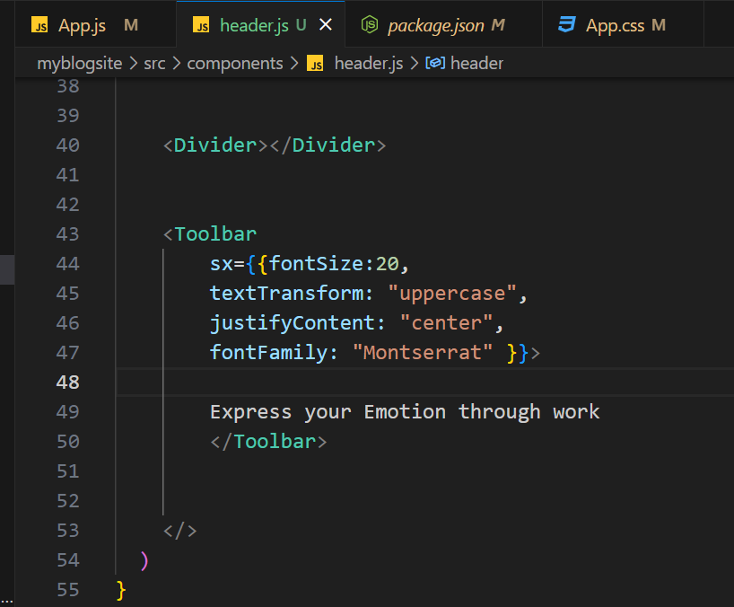

O/p

